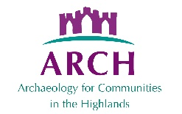
ARCH Heritage Course Module Guidance
The files in this folder provide guidance on facilitating community heritage courses, devised by Susan Kruse of ARCH over the years. They are for a ‘Community Timeline’ suite of courses which can be run separately or strung together. While many of the references are to resources in Highland Scotland, they could be adapted to other locations.
The guidance sheets also reference other handouts and forms. Some of these can be found in the ARCH Course Handouts and Forms folder in the Library of the ARCH website. They also refer to the Sites and Features outputs produced by these courses. Examples can be found in the Library for various ARCH projects produced in the past.
These materials were gathered together as part of the ARCH FACET project (Faciitated Community Engagement Training) where 5 trainees were trained in community heritage facilitation. The FACET project was funded by Historic Environment Scotland, ARCH, The Hugh Fraser Fund, Ardross Community Council (Beinn Tharsuinn windfarm benefit fund) and many donations. Further information about FACET is available on the ARCH website in the Projects folder.

